

**Course** : Diploma in Electronics & Computer Engineering (EGDF20)

**Module**  : Connected System Design Project (EGE205)

**Laboratory No**. : Lab 3a

**Laboratory Title** : HMI: Reading the Digital Inputs using BeagleBone Black Wireless (BBBW) Board

**Objective** : To connect hardware click boards and write python code to read different types

of digital input click boards.

**Hardware Boards** : BBBW Board with USB cable x1

: MikroBus Cape x1

: Tamper Click x1

: Keylock 2 Click x1

: 7Seg Click x1

**Contents**

1. Reading the Digital Input using BeagleBone Black Wireless (BBBW) Board
   1. Understanding of Tamper Click Hardware Connection
   2. Reading Digital Data from Tamper Click using Python Code
   3. Understanding of Keylock 2 Click Hardware Connection
   4. Reading Digital Data from Keylock 2 Click using Python Code
2. Displaying the Input Data using BeagleBone Black Wireless (BBBW) Board
   1. Developing a Press Counter using Tamper and 7Seg Click
   2. Tinkering Time

# **Reading the Digital Input using BeagleBone Black Wireless (BBBW) Board**

## Understanding of Tamper Click Hardware Connection

**Tamper Click** is equipped with a low-profile side-actuated detect switch. It is a high-quality, low-current detection switch, which is designed in the form of a push button. The switch itself is a very small with only 2mm of switch overtravel length, which coupled with its low actuation force, makes it ideal for using it as a contact detector in various applications such as consumer electronics devices, medical devices, smart card detection and other similar applications.

Tamper Click is also additionally equipped with the RC filter that minimizes the bouncing effect, making it a reliable solution for any contact detection application.

Tamper Click, and its respective schematic are shown in the Figure below.

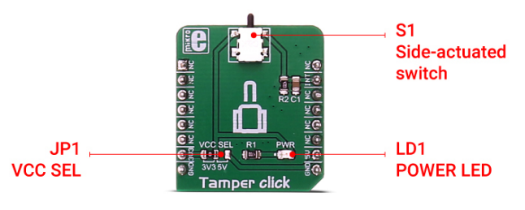

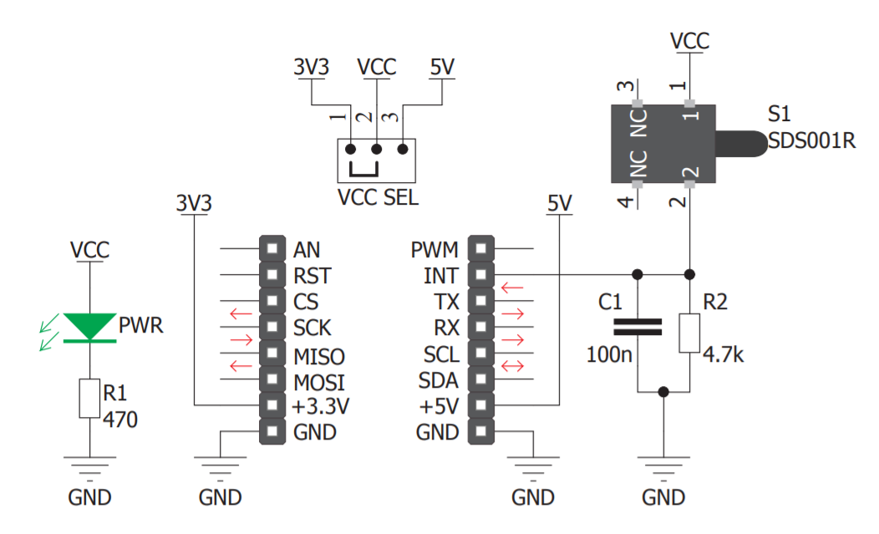

Figure 1.1a: Tamper Click and Schematic

1. **Connect** the Tamper Click to the mikroBUS cape and BBBW board as shown in the Figure below.

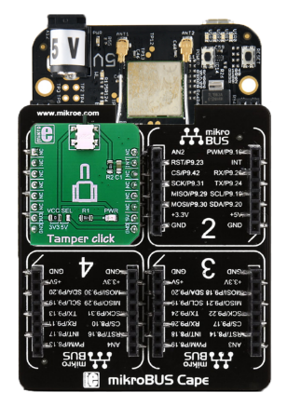

Figure 1.1b: Connecting Tamper Click to mikroBUS Cape and BBBW Board

## Reading the Digital Data from Tamper Click using Python Code

1. **Ensure** that the BBBW board is powered up and connected to the computer through a USB cable. **Open** the web browser (preferably Chrome browser) and **type** “**http://192.168.7.2:3000**” in the address bar.
2. **Right click** on the folder “**MyFirstPythonProject”** and **select** the “**New File**” from the drop-down menu to create a new python file. **Name** the file as “**Tamper.py**”.
3. **Double click** on the newly created file “**Tamper.py**” and enter the following code into the file under the Editor section.

|  |
| --- |
| import time  import Adafruit_BBIO.GPIO as GPIO  GPIO.setup("P9_15", GPIO.IN)  while True:  if GPIO.input("P9_15"):  print("Push Button is Pressed")  else:  print("Push Button is Not Pressed")  time.sleep(0.3) |

1. **Click** on the “Run” button located beside the Menu Tab to execute the “**Tamper.py**” file. It is observed that the text “**Push Button is Not Pressed**” is printed at the output console window.
2. **Press** **and hold** on the push button located on the Tamper Clickand it is observed that the text “**Push Button is Pressed**” is printed at the output console window.
3. **Release** the push button located on the Tamper Click and it is observed that the text “**Push Button is Not Pressed**” is again printed at the output console window.

## Understanding of Keylock 2 Click Hardware Connection

**Keylock 2 Click** carries an antistatic process sealed keylock mechanism that has three positions. It is intended to be used for implementation into applications which require mechanical lock mechanism, as well as for testing the same concepts in the early development stage. Because it can be easily installed in place of the standard lock, it is perfectly suited for development of various home security applications, industrial equipment etc.

Keylock 2 Click, and its respective schematic are shown in the Figure below.

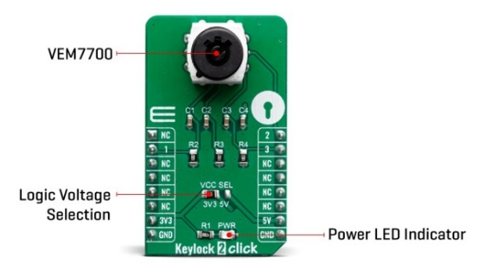

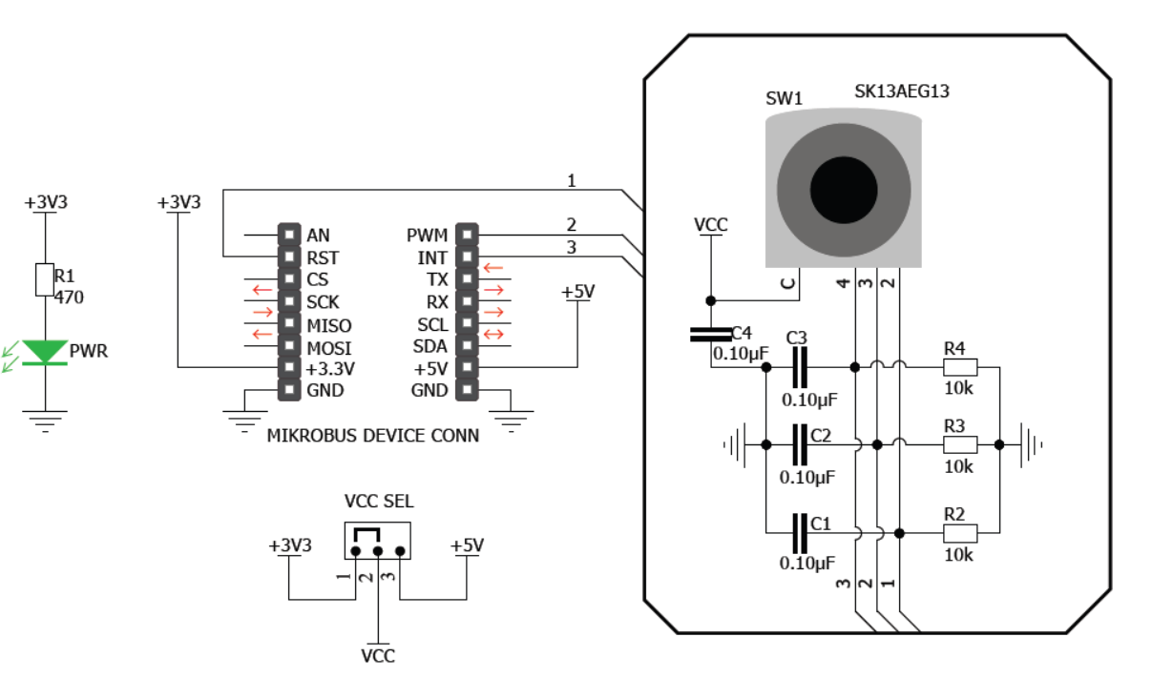

Figure 1.3a: Keylock 2 Click and Schematic

1. **Connect** the Keylock 2 Click to the mikroBUS cape and BBBW board as shown in the Figure below.

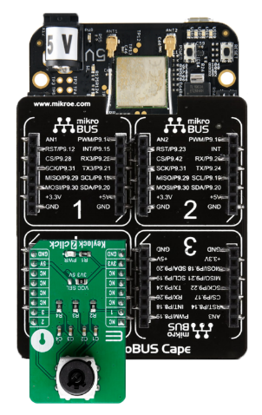

Figure 1.3b: Connecting Keylock 2 Click to mikroBUS Cape and BBBW Board

## Reading the Digital Data from Keylock 2 Click using Python Code

1. **Ensure** that the BBBW board is powered up and connected to the computer through a USB cable. **Open** the web browser (preferably Chrome browser) and **type** “**http://192.168.7.2:3000**” in the address bar.
2. **Right click** on the folder “**MyFirstPythonProject”** and **select** the “**New File**” from the drop-down menu to create a new python file. **Name** the file as “**Keylock2.py**”.
3. **Double click** on the newly created file “**Keylock2.py**” and enter the following code into the file under the Editor section.

|  |
| --- |
| import time  import Adafruit_BBIO.GPIO as GPIO  GPIO.setup("P8_16", GPIO.IN)  GPIO.setup("P8_13", GPIO.IN)  GPIO.setup("P8_17", GPIO.IN)  while True:  print(GPIO.input("P8_16"), GPIO.input("P8_13"), GPIO.input("P8_17"))  time.sleep(0.3) |

1. **Click** on the “Run” button located beside the Menu Tab to execute the “**Keylock2.py**” file. It is observed that the text “**1 0 0**” or “**0 1 0**” or “**0 0 1**” is printed at the output console window.
2. **Turn** the keylock located on the Keylock 2 Click to the left most position by using the keyand it is observed that the text “**1 0 0**” is printed at the output console window. The ‘1’ indicates that the keylock is currently in the position 1.
3. **Turn** the key to the clockwise direction to switch the keylock to the second and third position. It is observed that the text “**0 1 0**” followed by “**0 0 1**” is printed at the output console window.

# **Displaying the Input Data using BeagleBone Black Wireless (BBBW) Board**

## Developing a Press Counter using Tamper and 7Seg Click

1. **Connect** both the Tamper and 7Seg Clicks to the mikroBUS cape and BBBW board as shown in the Figure below.

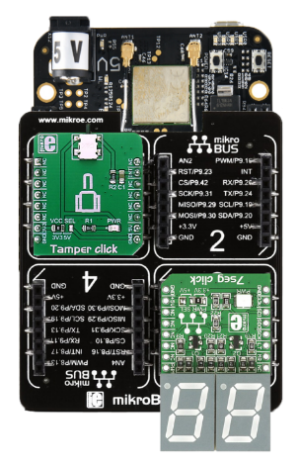

Figure 2.1a: Connecting both the Tamper and 7Seg Click to mikroBUS Cape and BBBW Board

1. **Ensure** that the BBBW board is powered up and connected to the computer through a USB cable. **Open** the web browser (preferably Chrome browser) and **type** “**http://192.168.7.2:3000**” in the address bar.
2. **Right click** on the folder “**MyFirstPythonProject”** and **select** the “**New File**” from the drop-down menu to create a new python file. **Name** the file as “**PressCounter.py**”.
3. **Double click** on the newly created file “**PressCounter.py**” and start entering the code below into the file under the Editor section.
4. **Enter** the code that imports all the necessary library to be used in the program as shown below.

|  |
| --- |
| from Adafruit_BBIO.SPI import SPI  import Adafruit_BBIO.GPIO as GPIO |

1. **Enter** the code of the 2 functions to be called in the program as shown below.

|  |
| --- |
| def SevenSegInit():  GPIO.setup("P8_19", GPIO.OUT)  GPIO.setup("P8_14", GPIO.OUT)  GPIO.output("P8_19", GPIO.HIGH)  GPIO.output("P8_14", GPIO.HIGH)  L_Spi0 = SPI(0,0)  L_Spi0.mode = 0  return L_Spi0  def SevenSegDisplay(L_Spi0, L_Number):  OnesDigit = L_Number % 10  TensDigit = L_Number / 10  L_Spi0.writebytes([DigitList[int(OnesDigit)], DigitList[int(TensDigit)]]) |

1. **Enter** the main code that reads the user input from Tamper Click and display the counting number on the 7Seg Click as shown below.

|  |
| --- |
| G_Number = 0  DigitList = [0x7E, 0x0A, 0xB6, 0x9E, 0xCA, 0xDC, 0xFC, 0x0E, 0xFE, 0xDE]  GPIO.setup("P9_15", GPIO.IN)  G_Spi0 = SevenSegInit()  SevenSegDisplay(G_Spi0, G_Number)  while True:  PressStatus = GPIO.input("P9_15")  if PressStatus:  G_Number += 1  if G_Number == 100:  G_Number = 0  SevenSegDisplay(G_Spi0, G_Number)  while PressStatus:  PressStatus = GPIO.input("P9_15") |

1. **Click** on the “Run” button located beside the Menu Tab to execute the “**PressCounter.py**” file.
2. **Press** on the push button located on the Tamper Click.
3. **Observe and compare** the output on the7Seg Click with your teammates and **consult** your lecturer for advice if it is not the same.
4. **Write** the observation in the white box below for future reference if needed.

|  |
| --- |
| *Right click and select “New comment” to insert your program as a comment.* |

## Tinkering Time

1. Together with a classmate or two, **think** of a simple application that can use either the Temper Click or Keylock2 Click to capture user’s input and feedback to user through BarGraph 2 Click, 7Seg Clicks, 8x8 R Click or OLED B Click.
2. **Connect** the selected clicks to the mikroBUS cape and BBBW board.
3. **Create** a python file in Cloud9 IDE and start writing your code.
4. **Present** your complete work to your lecturer for advice.
5. **Share** your work with your other classmates and teach them how you do it if they are interested.

*Congratulations! You have successfully completed the Lab3a. Good job! Take a good break and stay tune for next lab. More exciting lab exercises coming to you!*